What is the Digital Porter’s Five Forces Model?
Digital Porter’s Five Forces Model is a strategic analysis framework used to understand how digital technologies, platforms, online competition, and changing customer behaviour affect the level of competition within an industry.
It is based on Michael Porter’s traditional Five Forces Model, but applies the framework to a digital business environment.
The five forces are:
- Competitive Rivalry
- Threat of New Entrants
- Bargaining Power of Suppliers
- Bargaining Power of Buyers/Customers
- Threat of Substitutes
Simple definition
Digital Porter’s Five Forces helps a business understand how technology and digital platforms are changing competition and profitability in its industry.
Example: Food Delivery Industry
Let's use food delivery as an example.
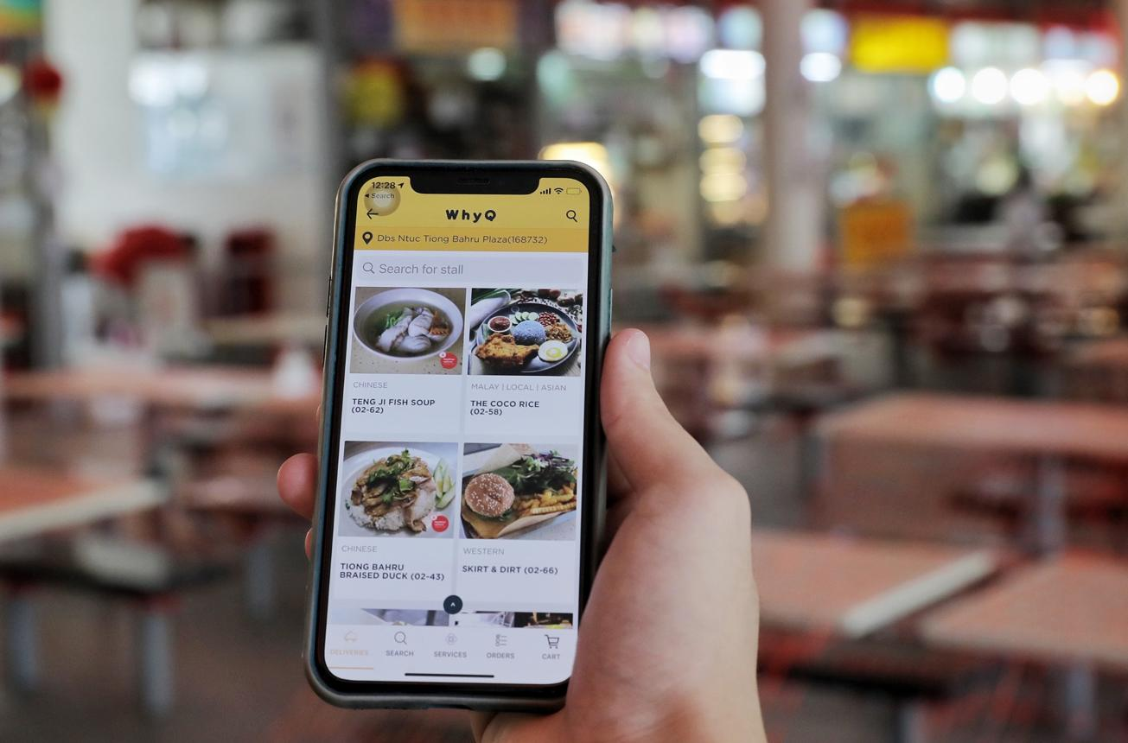
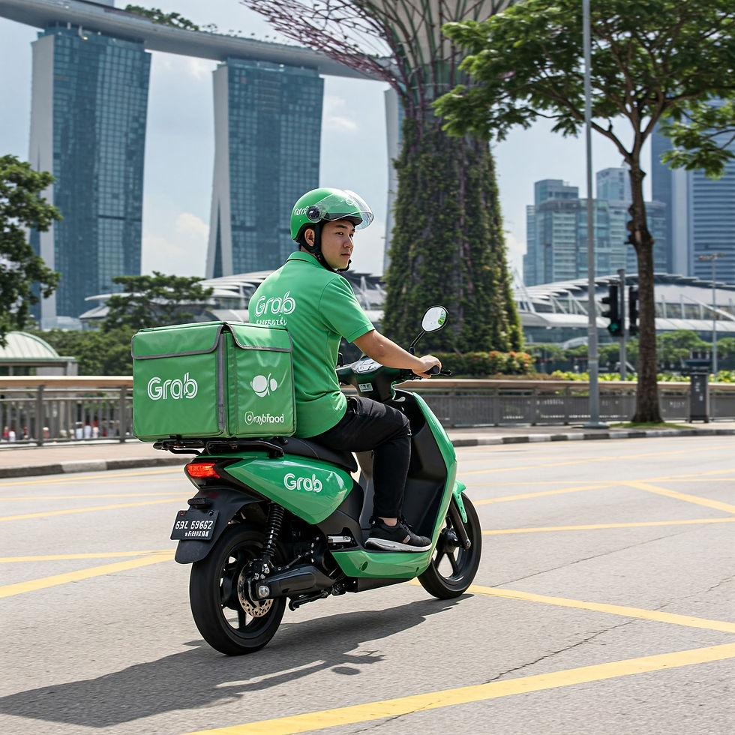
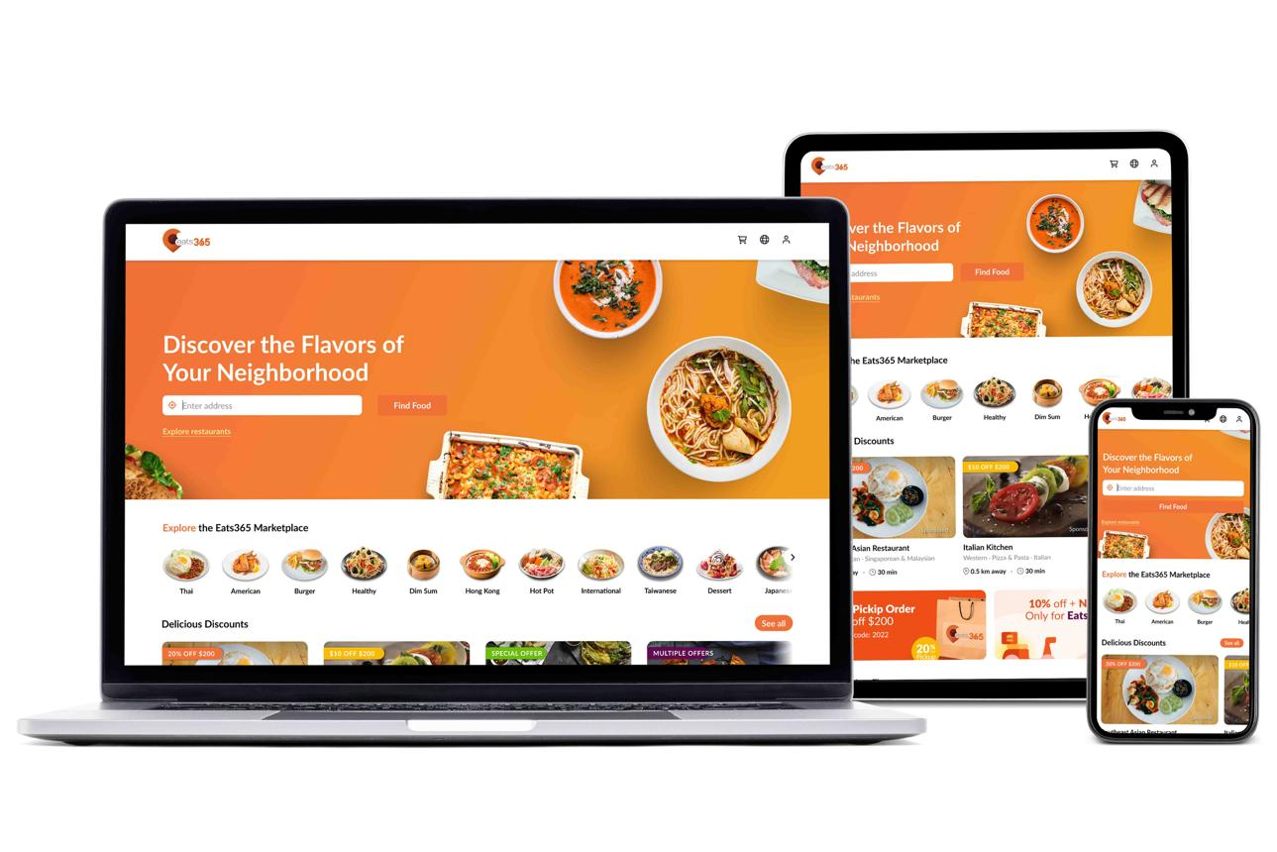

Imagine a company called QuickBite, which operates an online food-delivery platform.
1. Competitive Rivalry
Question:
How strongly are existing competitors competing with us?
In the digital environment, competition can be very intense because customers can easily compare different platforms.
Examples:
- Multiple food-delivery platforms compete for customers.
- Platforms offer discounts and promotional codes.
- Companies compete on delivery speed.
- Apps compete based on user experience.
- Restaurants may appear on multiple platforms.
Example
QuickBite competes with other food-delivery platforms by offering:
- Free delivery
- Loyalty programmes
- Faster delivery
- Personalised recommendations
- Exclusive restaurant partnerships
Digital impact: 🔴 High competitive rivalry
Because customers can switch between apps very easily.
2. Threat of New Entrants
Question:
How easy is it for a new company to enter the market?
Digital technology can make it easier for new businesses to enter some markets.
For example, a new food-delivery company can use:
- Cloud computing
- Third-party payment systems
- Ready-made mobile application frameworks
- Digital advertising
- Social media marketing
- Outsourced delivery services
Instead of building everything from scratch.
Example
A startup could launch a food-delivery website and mobile app with relatively low initial technology infrastructure costs.
However, it still needs to overcome challenges such as:
- Building a customer base
- Recruiting restaurants
- Establishing a delivery network
- Competing with established brands
- Obtaining sufficient funding

Digital impact: 🟠 Medium to High threat
Technology lowers some barriers to entry, but network effects and scale make it difficult to compete with established platforms.
3. Bargaining Power of Suppliers
Question:
How much power do suppliers have over the business?
For a food-delivery platform, suppliers could include:
- Restaurants
- Delivery riders
- Technology providers
- Payment providers
Example
Suppose QuickBite has only 50 restaurants.
A popular restaurant could say:
"We will only stay on your platform if you reduce your commission."
Because the restaurant is important to customers, QuickBite may have to negotiate.
On the other hand, if QuickBite has thousands of restaurants, an individual restaurant has less bargaining power.
Digital impact: 🟠 Medium
Digital platforms can reduce supplier power by providing access to many alternative suppliers, but popular suppliers can still have significant influence.

4. Bargaining Power of Buyers/Customers
Question:
How much power do customers have?
Digital technology generally increases customer power.
Customers can:
- Compare prices instantly.
- Compare restaurant ratings.
- Read reviews.
- Compare delivery times.
- Switch between apps.
- Find promotional discounts.
Example
A customer wants to order pizza.
They can open several apps and compare:
Platform | Pizza | Delivery | Promotion
QuickBite | $20 | $3 | $5 voucher
Platform B | $19 | $2 | Free delivery
Platform C | $21 | $0 | 10% cashback
The customer can easily choose the best option.
Digital impact: 🔴 High buyer power
Because switching costs are very low.

5. Threat of Substitutes
Question:
Are there alternative ways customers can satisfy the same need?
A substitute isn't necessarily another food-delivery company.
Customers could instead:
- Cook at home.
- Eat at the restaurant.
- Pick up takeaway themselves.
- Order directly from the restaurant.
- Buy ready-to-eat meals from supermarkets.
Example
Instead of using QuickBite, a customer might order directly from a restaurant's website and avoid delivery-platform fees.
Or they might simply cook dinner at home.
Digital impact: 🟠 Medium to High
Digital technology creates more alternatives, including direct-to-consumer ordering.

Complete Digital Porter’s Five Forces
Force | Example in Food Delivery | Level
Competitive Rivalry | Multiple delivery platforms compete through discounts, speed and UX | 🔴 High
Threat of New Entrants | Technology makes it easier to launch a platform | 🟠 Medium–High
Supplier Power | Popular restaurants and riders can negotiate terms | 🟠 Medium
Buyer Power | Customers can easily compare prices and switch apps | 🔴 High
Threat of Substitutes | Cooking, takeaway, direct restaurant ordering | 🟠 Medium–High

Another Example: Netflix / Video Streaming
Digital Porter’s Five Forces becomes even clearer with the video-streaming industry.
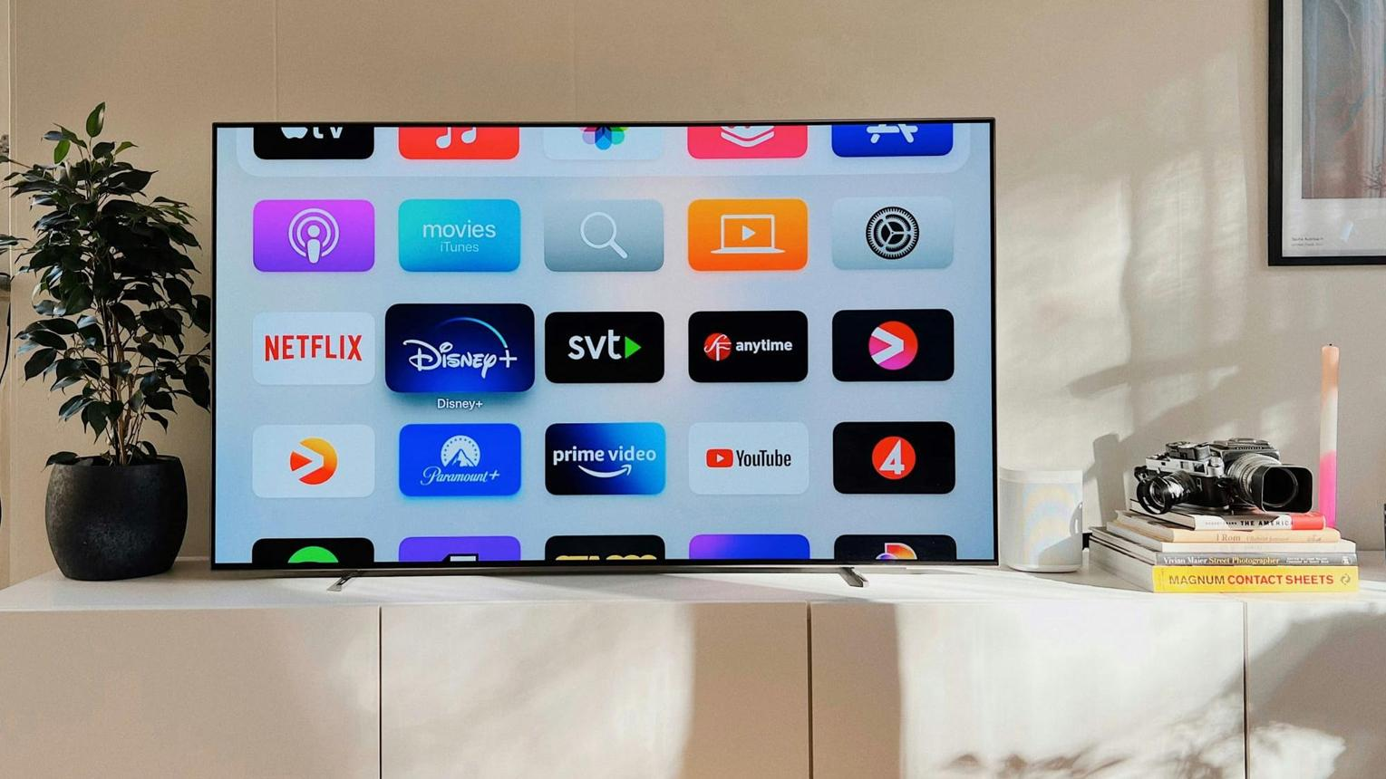
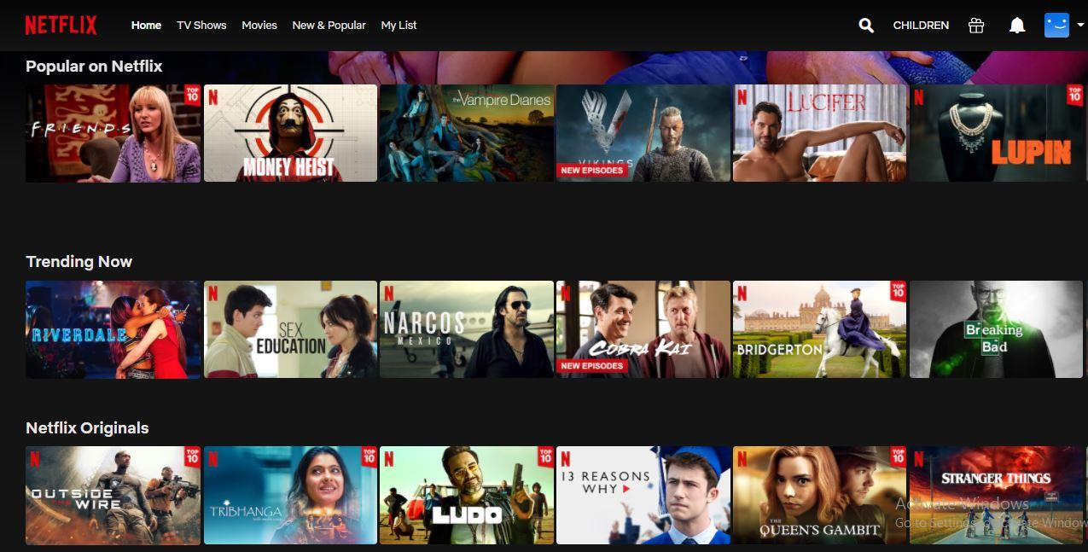
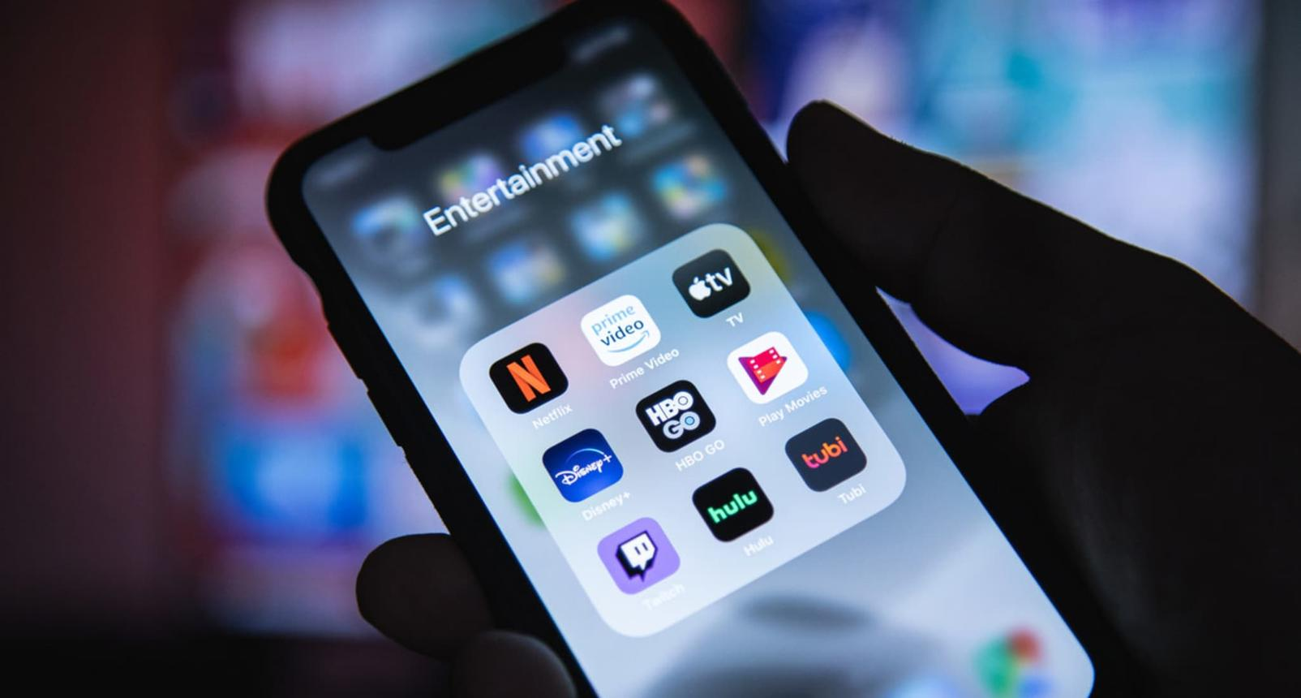

1. Competitive Rivalry — High
Streaming platforms compete through:
- Exclusive content
- Subscription prices
- Original productions
- User experience
- Personalised recommendations
2. Threat of New Entrants — Medium
Cloud technology makes it easier to distribute video globally, but creating a competitive streaming service requires enormous investment in:
- Content
- Technology
- Marketing
- Licensing
3. Supplier Power — High
Content creators and studios can have significant power because popular movies, shows and sports rights attract customers.
For example:
Exclusive access to a highly popular programme can make a streaming platform much more attractive.
4. Buyer Power — High
Customers can cancel subscriptions easily and move to another platform.
For example:
Netflix → Disney+ → Amazon Prime Video → YouTube
Switching is relatively easy.
5. Threat of Substitutes — High
Customers don't have to use streaming services.
Substitutes include:
- YouTube
- Social media
- Gaming
- Traditional television
- Cinema
- Podcasts
- User-generated content

How Digital Technology Changes Porter's Five Forces
This is the most important concept for students.
Digital technology can change the strength of each force:
Digital Development | Effect
Mobile apps | Makes switching between competitors easier
Online reviews | Increases customer power
AI | Improves personalisation and creates competitive advantages
Cloud computing | Can lower barriers for new entrants
E-commerce platforms | Connect businesses with many customers and suppliers
Social media | Makes customer opinions more influential
Digital marketplaces | Can increase competition between suppliers
Data analytics | Helps businesses understand and retain customers
Automation | Can reduce operating costs
Network effects | Can make established platforms difficult to challenge

Digital SWOT vs Digital PESTLE vs Digital Porter
These three models answer different questions:
Framework | Main Question
Digital PESTLE | 🌍 What external environmental changes could affect the business?
Digital Porter’s Five Forces | ⚔️ How competitive is the digital industry?
Digital SWOT | 🎯 What are the organisation's strengths, weaknesses, opportunities and threats?

A simple strategy process
You can teach students to use them in this sequence:
Step 1 — Digital PESTLE
"What is happening in the external environment?"
⬇️
Step 2 — Digital Porter’s Five Forces
"How is this affecting competition in our industry?"
⬇️
Step 3 — Digital SWOT
"Given the environment and competition, what are our strengths, weaknesses, opportunities and threats?"
⬇️
Step 4 — Digital Strategy
"What should the organisation actually do?"
Example
PESTLE: Customers increasingly use mobile devices for food ordering.
→ Porter: Buyer power increases because customers can easily compare platforms.
→ SWOT: Opportunity to develop a better mobile ordering experience.
→ Strategy: Invest in a personalised mobile app with loyalty rewards.
This is how the three frameworks can work together rather than being treated as separate theoretical models.

